TIP SHEET:
Using the Medicine Wheel to Communicate

Good communication and learning how to resolve conflict is an important skill for developing empathy and resilience in children as well as building healthy family relationships. The Medicine Wheel is an important teaching tool that connects families to ancient wisdom and traditional values passed down over many generations. There are four important aspects of self. We have a physical self, emotional self, mental self and spiritual self. Taking care of each of these aspects is an important part of being healthy. We exercise and eat good foods to maintain our physical self; being loved is important to our emotional self; learning develops our mental self; and being connected to nature nourishes our spiritual self.

The journey to wellness involves learning to communicate with others in healthy balanced ways. The Communication Wheel and following examples were developed by GONA Trainer and Wellness Coach Maria Trevizo to show how the words we use to start conversation can tap into each aspect.

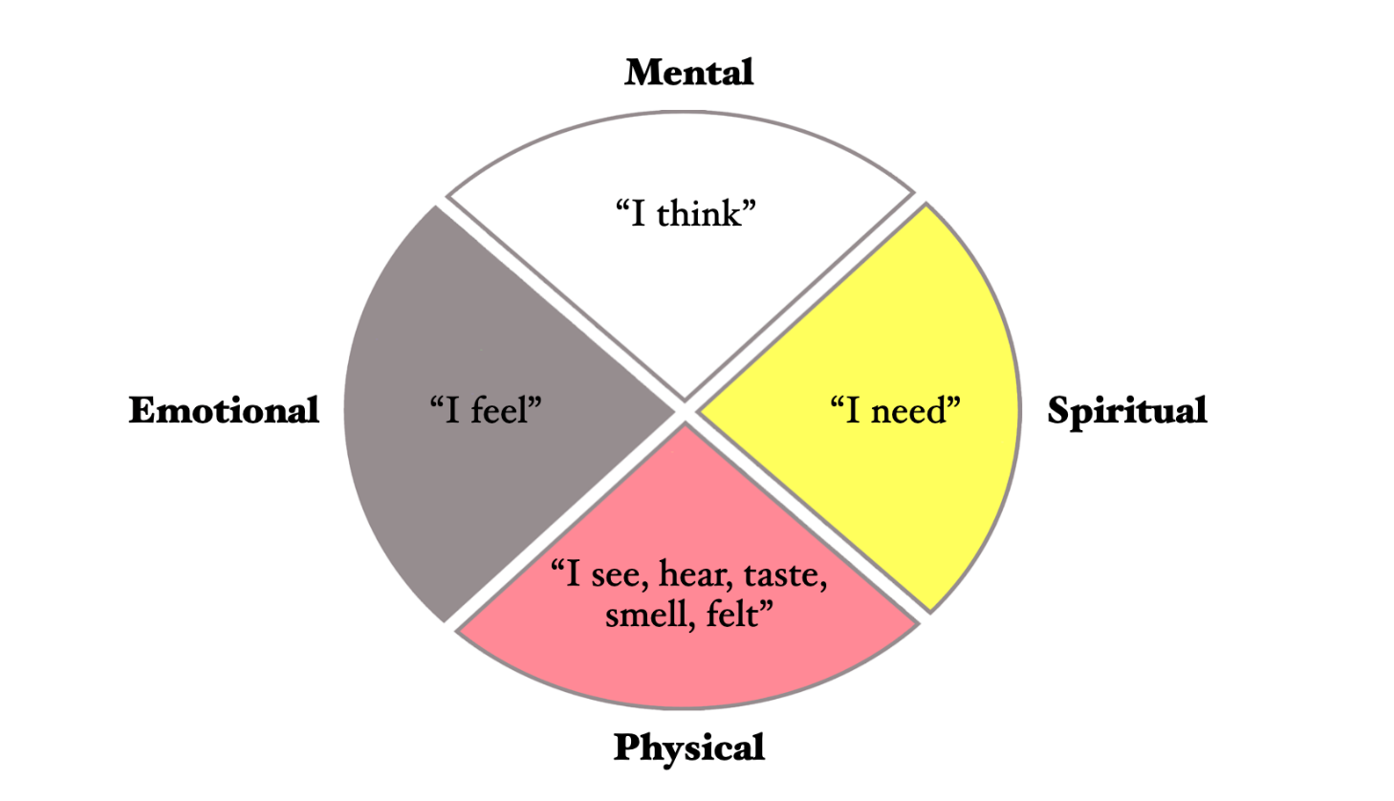

Parenting is a challenging but rewarding job. Children learn to communicate by observing others around them. If parents are able to communicate openly and effectively, it’s likely that their child(ren) will too. Effective communication teaches respect, makes children feel heard, supporting self-esteem and good coping strategies. The following ways are examples of how you as a parent can use the Medicine Wheel to support positive communication and behavior:
Emotional: Express how we feel without attacks or name calling

- I felt scared when you ran in the parking lot.
- I feel angry when you don’t follow the rules.
- I was proud when you put your toys away.
- I was sad that you were hurt.

Physical: Report how and what we witnessed

- I saw you take a cookie after I said “no.”
- I heard you call her names.
- It hurts when you hit me.
- You are always hiding when it’s time for bed.

Mental: We say what made us think and to state expectations

- It makes me think that you don’t respect our family rules.
- It makes me think that you feel it’s okay to steal.
- I expect all of these toys to be put away.
- I expect you to return that toy to your brother.

Spiritual: We speak what we need to happen and show the child how to make amends

- I need you to hold my hand when we cross the street.
- I need you to ask for what you want.
- What she needs is an apology and a hug.
- Please show me how you take care of your toys when you are done playing with them.

Remember that modeling good communication also requires parents to listen to their child with full attention. Instead of questions and advice, there are times when acknowledging the child’s feelings or a word to express a thought the child is trying to express can encourage problem solving.

