Learning to Write and Draw
Excerpt From Zero to Three National Center for Infants, Toddlers and Families

Creativity is a bridge to learning. When your child is creative and curious,
she can come up with answers to the problems she encounters. Creativity helps your child become a thoughtful, inquisitive, and confident learner later on, when she starts
school. One of the most important ways that your toddler is tuning in to her creativity is by experimenting with art materials.

*Note that the timetables listed below are approximate; your child may
master these skills faster or slower and still be developing just fine. Growth doesn’t happen at the same speed for every child, but by offering repeated fun experiences with a variety of art and writing materials, you will see forward progress over time.

Stage 1: Random Scribbling (15 months to 2 1/2 years): This is the period when young children are just figuring out that their movements result in the lines and scribbles they see on the page. These scribbles are usually the result of large movements from the shoulder, with the crayon or marker held in the child’s fist. There is joy in creating art at all ages, but at this stage especially, many children relish the feedback they are getting from their senses: the way the crayon feels, the smell of the paint, the squishy-ness of the clay.For other children, this sensory information may be too much and they may not enjoy some art activities at this stage (like finger-painting).

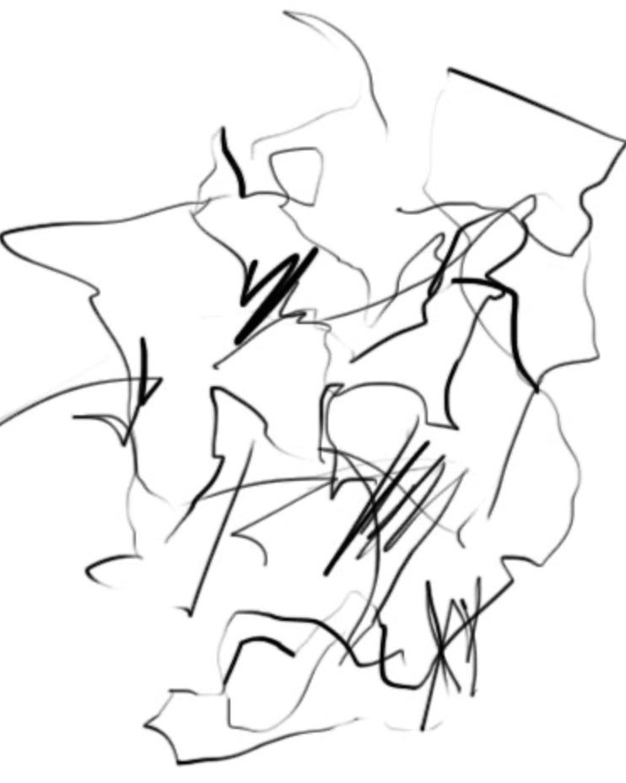
Stage 2: Controlled Scribbling (2 years to 3 years):
As children develop better control over the muscles in their hands and fingers, their scribbles begin to change and become more controlled. Toddlers may make repeated marks on the page—open circles, diagonal, curved, horizontal or vertical lines. Over time, children make the transition to holding the crayon or marker between their thumb and pointer finger.

Stage 3: Lines and Patterns (2 1/2 years to 3 1/2 years):
Children now understand that writing is made up of lines, curves, and repeated patterns. They try to imitate this in their own writing. So while they may not write actual letters, you may see components of letters in their drawing. These might include lines, dots and curves. This is an exciting time as your toddler realizes that his drawing conveys meaning! For example, he may write something down and then tell you what word it says. This is an important step toward reading and writing.

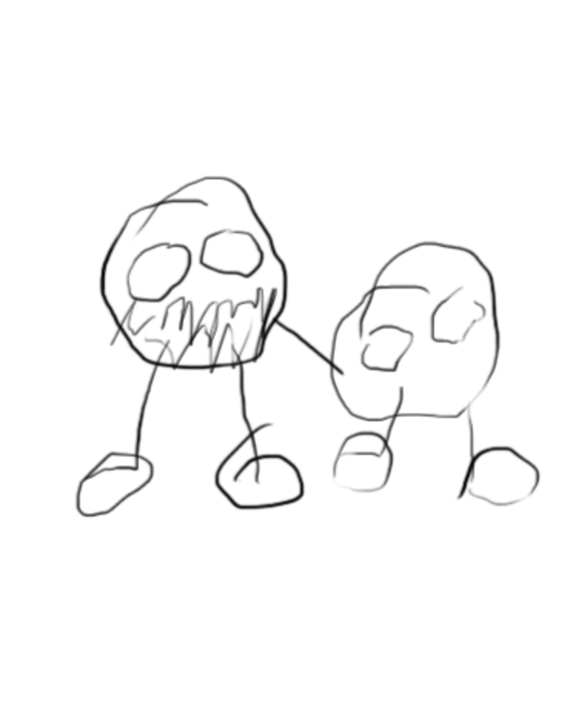
Stage 4: Pictures of Objects or People (3 years to 5 years):
At first, children name their unplanned creations. This means that they finish the picture and then label their masterpiece with the names of people, animals, or objects they are familiar with. This changes over time. Soon you will see your child clearly planning prior to drawing what he will create. You will also see more detail in the pictures, more control in the way your child handles the crayon or marker, and the use of more colors. What else to be on the lookout for? Children’s first pictures often build off circles. So, you may see a sun—an irregular circle, with lots of stick “rays” shooting out—or a person (usually a circle with roughly recognizable human features).
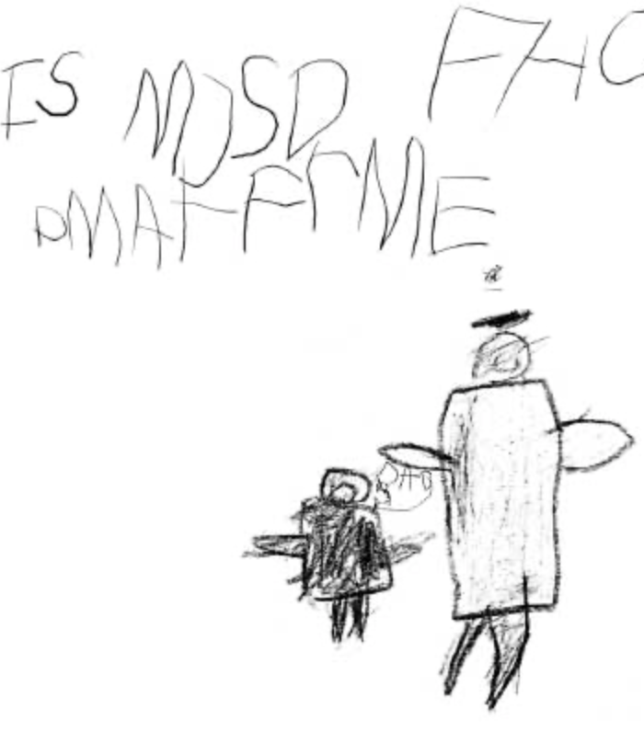
Stage 5: Letter and Word Practice (3 to 5 years):
Children have had experience with letters and print for several years now and are beginning to use letters in their own writing. Usually children start by experimenting with the letters in their own names, as these are most familiar to them. They also make “pretend letters” by copying familiar letter shapes, and will often assume that their created letter must be real because it looks like other letters they have seen (Robertson, 2007). During this time, children also begin to understand that some words are made of symbols that are shorter and some words are made of symbols that are longer. As a result, their scribbles change. Rather than one long string of letters or letter-like shapes, your child's writing now has short and long patterns that look like words or sentences. While these letters and words are probably not technically correct, it does not matter. This exciting milestone means that your child is beginning to understand that text and
print have meaning.

References:
Farrell-Kirk, R. (2007 February). Tips on understanding and encouraging your child’s artistic development. Dowloaded on June 10, 2008
Gable, S. (2000). Creativity in young children. University of Missouri Extension. Dowloaded on June 10, 2008
Kentucky Cooperative Extension Service. (no date). My child is an artist! The Stages of artistic development. Dowloaded on June 10, 2008
Lagoni, L. S., Martin, D. H., Maslin-Cole, C., Cook, A., MacIsaac, K., Parrill, G., Bigner, J., Coker, E., & Sheie, S. (1989). Good times being creative. In Good times with child care (pp. 239-253). Fort Collins, CO: Colorado State University Cooperative Extension. Dowloaded on June 10, 2008
Levinger, L, & Mott, A. (no date). Developmental phases in art. Dowloaded on June 10, 2008
Robertson, R. (2007, July/August). The Meaning of marks: Understanding and nurturing young children’s writing development. Child Care Exchange, 176, 40-44.

