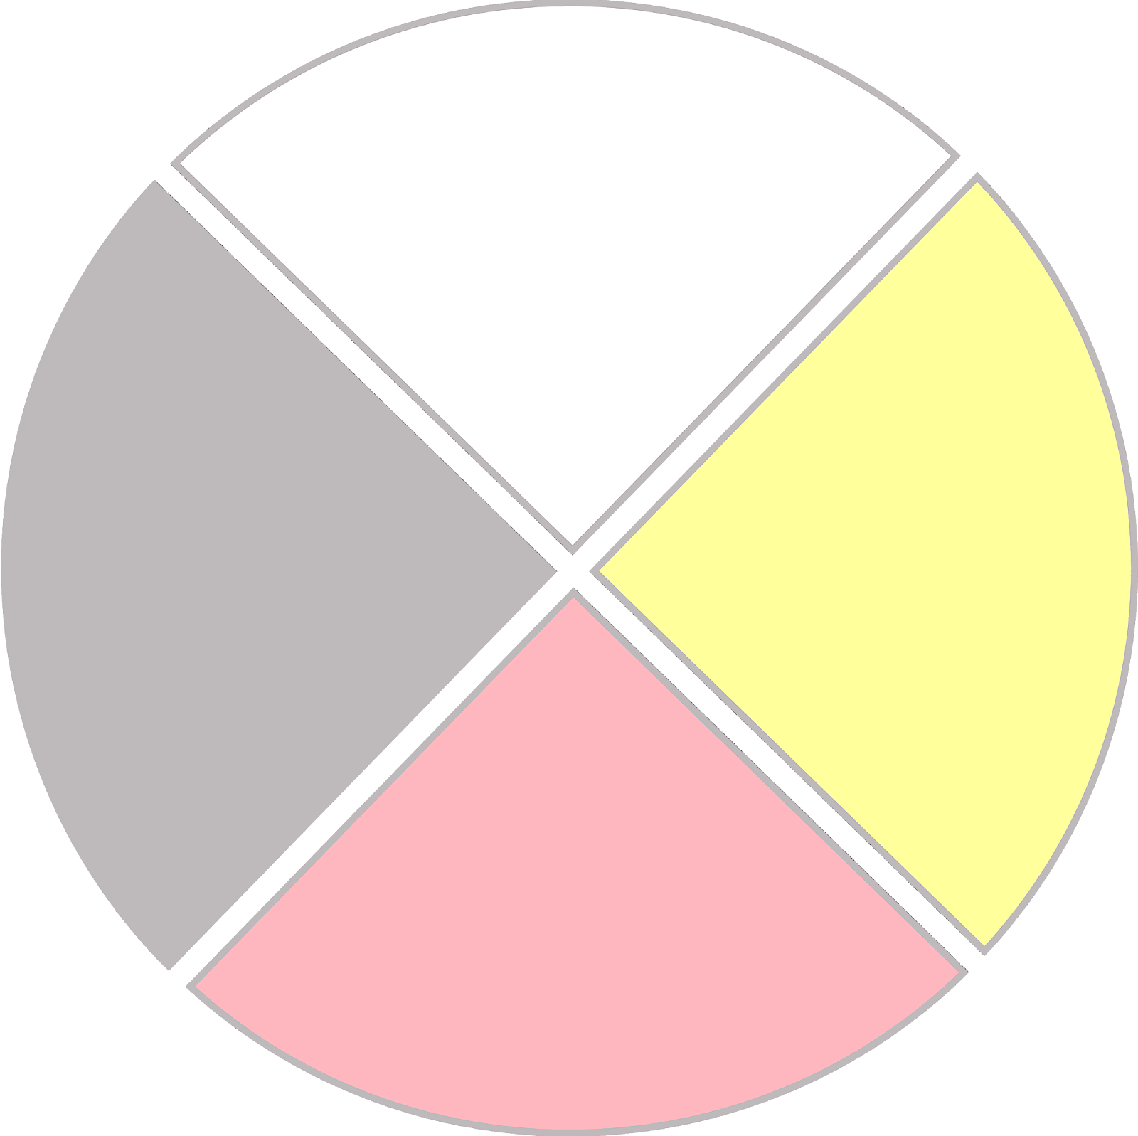
Gikinawaabi: Observation as the Foundation of Learning
Early Learning Supplementary Curriculum
Inter-Tribal Council of Michigan

