Breast and Cervical Cancer Control Navigation Program is ready to help

Whether insured or not, the Breast and Cervical Cancer Control Navigation Program (BC3NP) will help women receive the care they need.

The BC3NP can arrange for program-eligible women to receive breast and cervical cancer screenings, follow-up care for an abnormal test result, and treatment – if breast or cervical cancer is diagnosed.

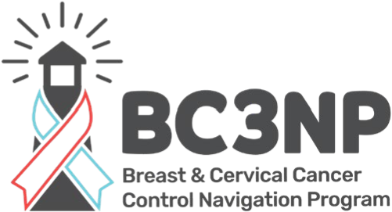
Eligible women must be between the ages of 21-64 (cervical) and 40-64 (breast)

Low or No-cost
Breast
and
Cervical

Cancer Services
Available for Women
# of people  in the household | Yearly  Income | # of people  in the household | Yearly  Income | # of people in the household | Yearly  Income
1 | $33,975.00 | 3 | $57,775.00 | 5 | $81,175.00
2 | $45,775.00 | 4 | $69,375.00 | 6 | $92,975.00
with an income ≤ 250 % of the Federal Poverty Level.

- Uninsured women can enroll in the program and receive cancer screening services (mammograms and Pap tests) at no cost.

- Underinsured women (women with high deductibles) may receive screening and/or diagnostic services not paid by their insurance.

- Insured women can receive assistance by program navigators to receive screening, diagnostic and/or treatment services.

- Women diagnosed with breast or cervical cancer may also be eligible to receive treatment through the BC3NP Medicaid Treatment Act (MTA).
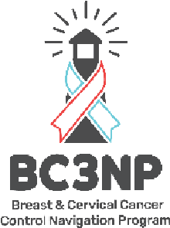

April 2022

Call Emily at Mina Mskiki Gumik (231)-242- 1772 to find out if you are eligible to receive program services.

