Lesson 7 (Nizhwaaswi): Alphabet Books

Lesson Objective:
The child will learn to recognize letters of the alphabet visually and be able to name them as they see them.

Medicine Wheel Wisdom
As we walk through the different directions in the medicine wheel we move at a speed that is right for us. When a child learns their letters it happens at their own pace and that is OK!

Use the checklist below to help introduce the lesson to the family. These items are actions that we hope to support in our work with the family.

Family Outcomes (PICCOLO):
- Attends to the child’s cues with respect and support.
- Praises the child for their efforts in learning the activity
- Helps label objects and the child with the letters if needed

Child Behavior Outcomes (LOLLIPOP):
- Is able to identify the letters of the alphabet
- Identifies and understands the letters and their symbols
- Understands upper and lower case letters

Home Visitor Lesson Overview:

Materials Needed:
- “Anishinaabemowin Alphabet” Book
- “Show Me My Name” and “Capital Letter Formation Chart”
- Sentence Writing Strips
- Tip-Sheet: “Alphabet Knowledge”

Lesson:

- Explain to the parent that learning the alphabet is a process.
  - In the Medicine Wheel learning the alphabet is in the Eastern Direction
  - Learning the alphabet is a critical step for a child to learn how to read and the earlier the child begins to learn the better
  - The child will learn at their own pace and that is OK!

- Read the alphabet book starting out with the statement “these are the letters of the alphabet”.
  - During the book identify letters that may be familiar to the child. For instance, the first letter of their name, other letters in the child’s name.

- Write the child’s name on the sentence strip referring to the “Show Me My Name” materials to ensure proper letter formation. Say out loud each letter as you write it.

- Keep in mind as you complete the activity that it is important for young children to be able to eventually:
  - Recognize and name letters.
  - Recognize beginning letters in familiar words (especially their names).
  - Recognize both capital and lowercase letters.
  - Relate some letters to the specific sounds they represent

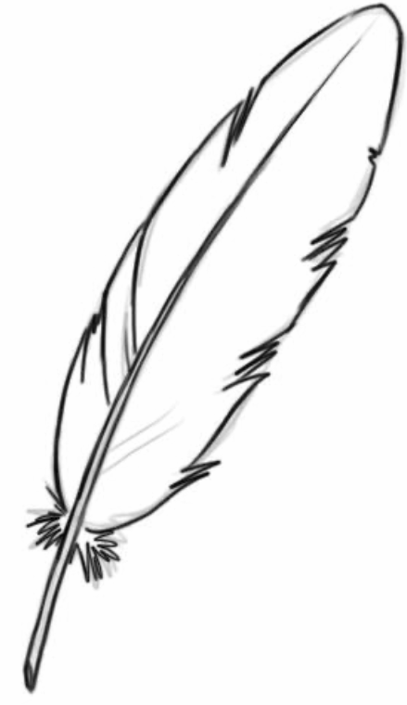
Children learn and develop at different stages. This is okay! Just keep encouraging their own growth!

- Give the child a blank sentence strip and encourage them to attempt to write their name.

- The final step is to transition the caregiver to lead the activity with the child with reading and helping write the child’s name.

Lesson Wrap-Up:
- Tip-Sheet: “Alphabet Knowledge”
- “Show Me My Name” and “Capital Letter Formation Chart”
- Sentence Writing Strips
- Explain Lesson 7 Activity

